The Plot twist library

Code changes
- Add user functionality
- Borrow history functionality
- Log out function
- Staff dashboard current activity grid
- Summary buttons for staff creen on total books out ……
- Add description to books Json file
- Staff reports
- Helpers

WPF design

Design choices
- Keep the first screen very simple, because its only job is identification.
- Use a top navigation bar after login so the user always knows where they are.
- Use tables/DataGrids for books and loans, since library data is naturally tabular.
- Show quick actions on dashboards so the app feels faster to use.
- Separate staff and user dashboards so regular users don’t see admin controls they can’t use.

First screen: Member ID entry
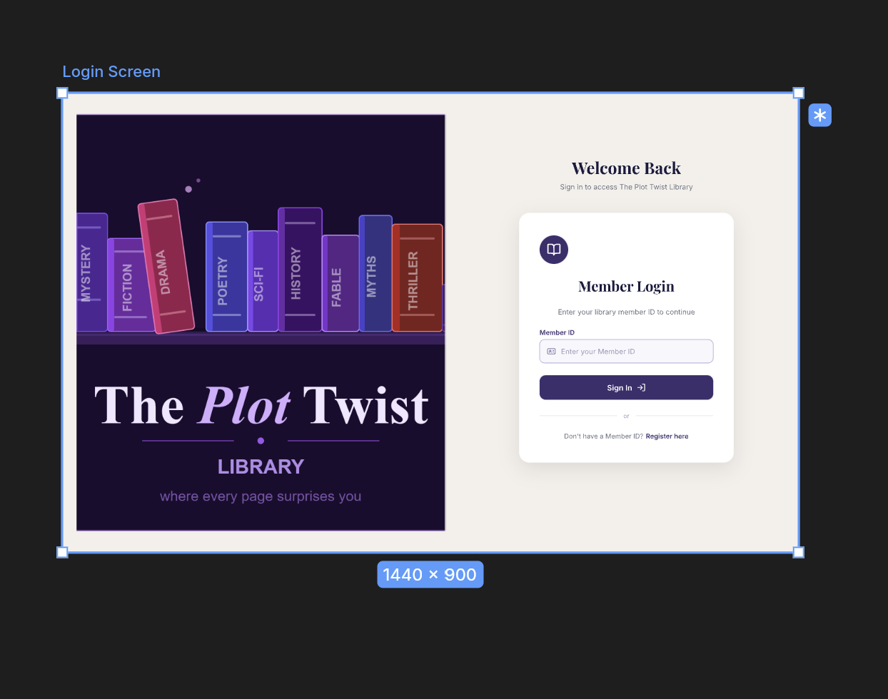

2. Library user dashboard
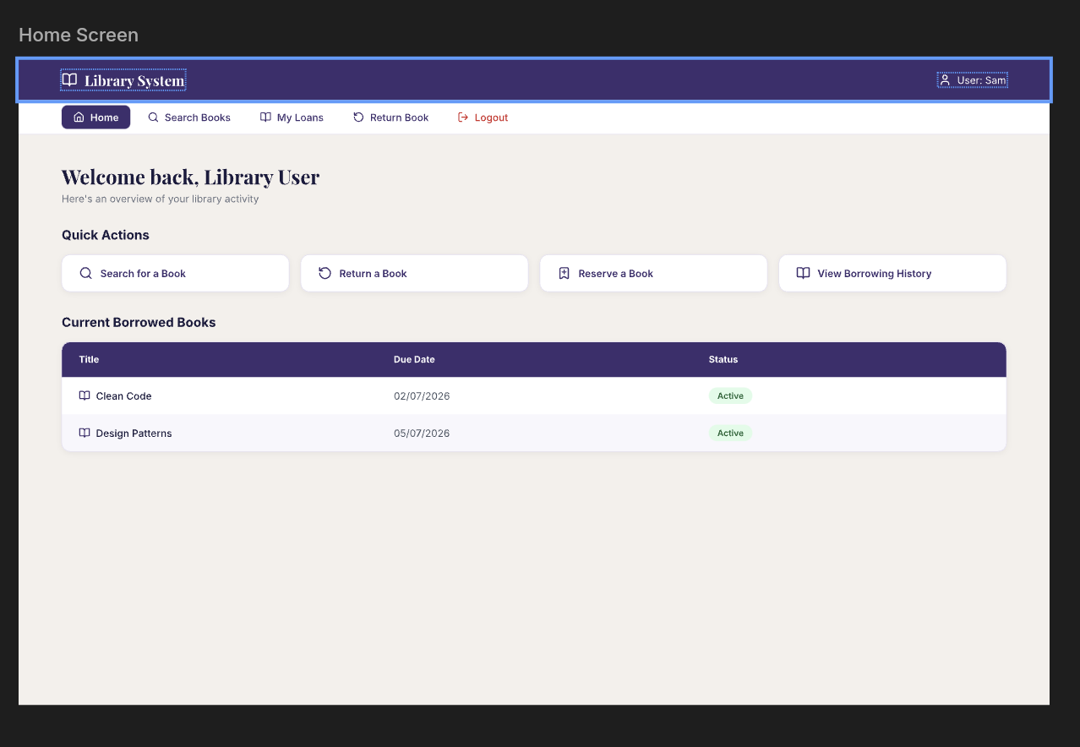

3. Staff dashboard
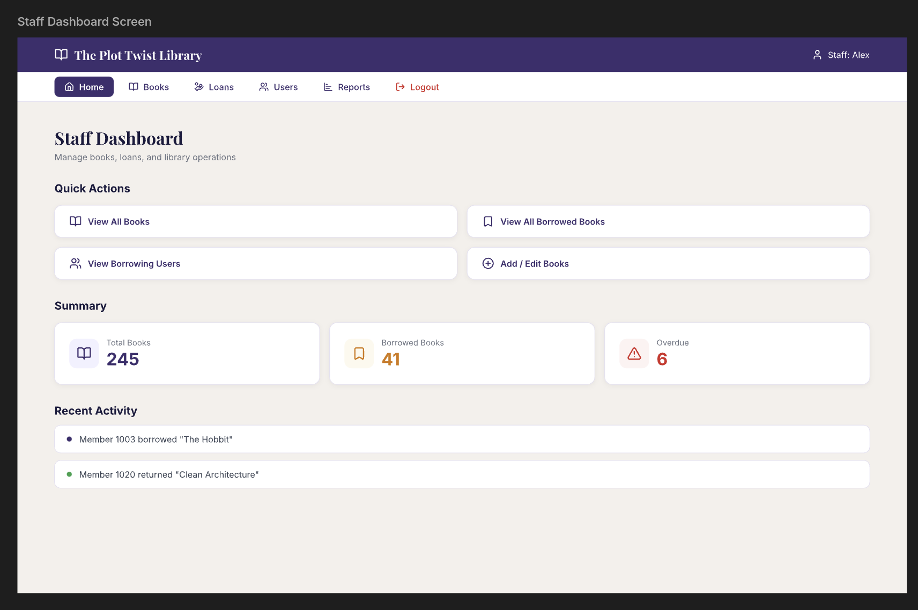

4. Search books screen

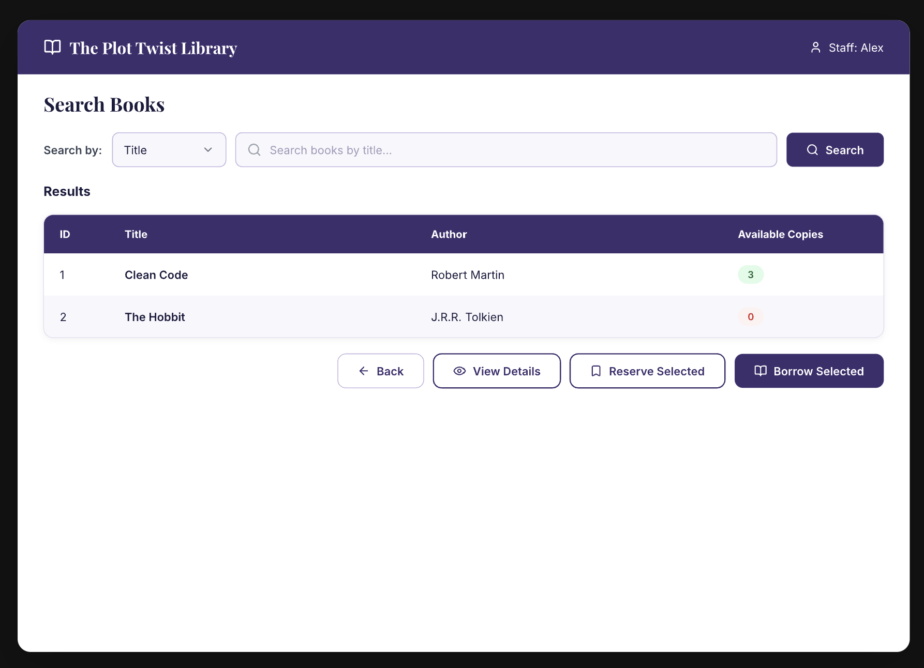5. Book details screen
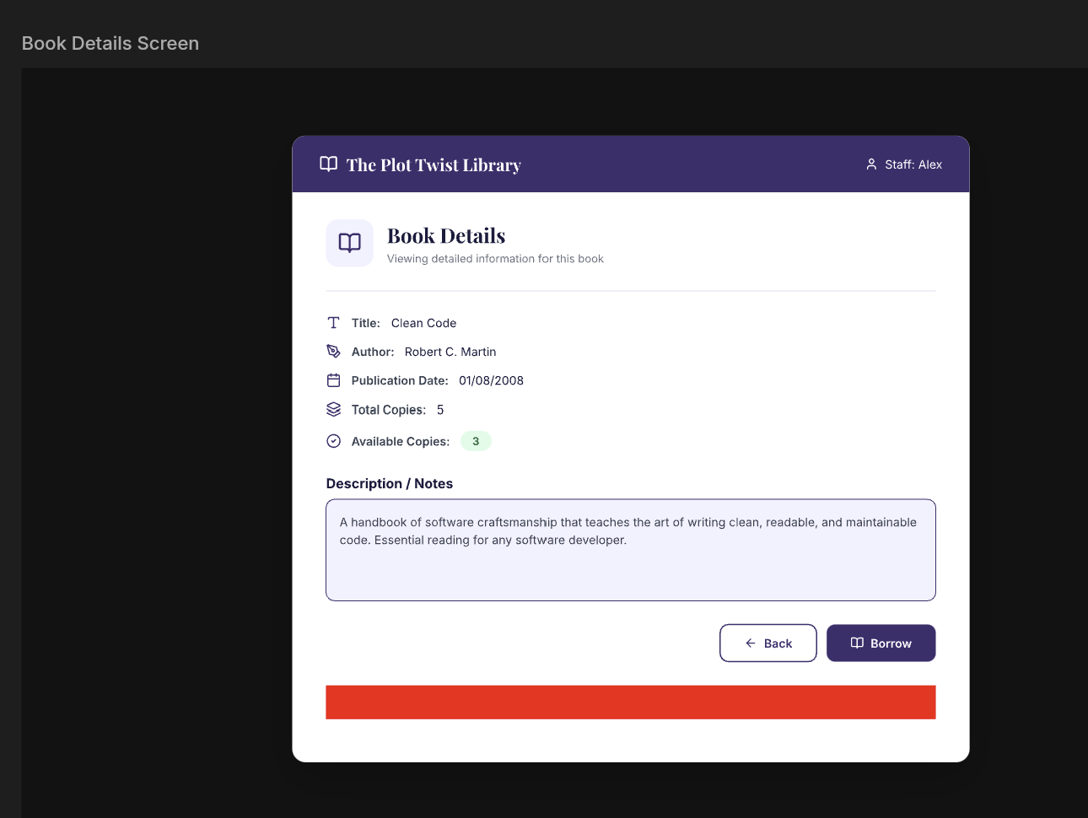

6. Staff report screen
text
+----------------------------------------------------------------+
| Borrowing Reports |
|----------------------------------------------------------------|
| [ All Borrowed Books ] [ Users With Borrowed Books ] |
| |
| ------------------------------------------------------------ |
| User Name Book Title Due Date Status |
| John Smith Clean Code 02/07/2026 Active |
| Mia Lee The Hobbit 28/06/2026 Overdue |
| ------------------------------------------------------------ |
| |
| [ Export ] [ Refresh ] [ Back ] |
+----------------------------------------------------------------+

WPF structure
- MainWindow
- LoginView
- UserDashboardView
- StaffDashboardView
- separate views for SearchBooks, BookDetails, Loans, and Reports

Code Structure
- Models
  - Member, Book, Loan, Staff, etc.
- Services
  - LibrarySystem, maybe LoanService, AuthService later
- Views (or Windows)
  - LoginWindow, UserDashboardWindow, SearchBooksWindow, StaffDashboardWindow
- ViewModels
  - BorrowedBookViewModel, future SearchBooksViewModel, etc.
- Controls
  - Reusable bits of UI like your future HeaderBar, UserBadge
- Helpers / Utilities
  - WindowHelpers,

